1. **INTRODUCTION**

**1.1 Motivation**

The main objective of our project is to develop a College Chatbot system for colleges. The college materials can also be maintained using the software. The teachers can send materials just by uploading them to the drive folder. So that the all students can get their materials using the chatbot.

**1.2 Problem Statement**

Chatbots greatly help in reducing the valuable time of your customer care personnel by taking care of routine queries. It then transfers the control of communication over to the organization’s representative after the requirements of the customer have been established.

We can make “1 to many relationship” with chatbot and we can reduce cost on customer care services with efficient chatbot.

**1.3 Objectives**

The purpose of this project is to define the requirements of mark chatbot system. This system reduces manual work to great extent.

The chatbot is carried out by the system in an efficient manner. The main objective is to answer all type of questions of a student in a efficient way.

This system can be used for all kinds of educational institutions to answer questions and give them required answers and materials to student.

**Working:**

We can define the chatbots into two categories, following are the two categories of chatbots:

1. **Rule-Based Approach** – In this approach, a bot is trained according to rules. Based on this a bot can answer simple queries but sometimes fails to answer complex queries.
2. **Self-Learning Approach –**These bots follow the machine learning approach which is rather more efficient and is further divided into two more categories.

**They are of follows -**

1. **Retrieval-Based Models** – In this approach, the bot retrieves the best response from a list of responses according to the user input.
2. **Generative Models** – These models often come up with answers than searching from a set of answers which makes them intelligent bots as well.
3. **Literature Survey**

. **2.1 Existing work**

Teachers has to talk to the students and need to send the materials to them through WhatsApp, Gmail or so on. Both the teacher and student have to be free at same time so that their work may go well.

**2.2 Limitations of Existing work**

* Sharing of materials will be only “one to one only”
* Time complexity is more.
* Sharing one to one makes loss of data and materials.

1. **Software Requirements Specifications**

**3.1 Overall Description**

**CCS** – College Chatbot System.

**Administrator:** The person who adds materials to drive and train’s the bot to answer questions more correctly.

**Database:**  It contains all required information about college.

**3.2 Operating Environment**

MS-WINDOWS.

**3.3 Functional Requirements**

The Functional Requirements of the college chatbot is as follow.

**Functional Requirements of Admin:**

Admin plays a major role in this project. Admin has all authorities to manipulate the data in database.

* Adding college information daily.
* Updating the results and materials.
* Adding new training phares, to make to efficient.

**3.4 Non-Functional Requirements**

The non-functional requirements the system should satisfy are

**Scalability:**

scalability is an attribute of a tool or a system to increase its capacity and functionalities based on its users' demand. Scalable software can remain stable while adapting to changes, upgrades, overhauls, and resource reduction.

**User Interface:**

It has a well-defined user interface to chat properly and can understand easily.

**Serviceability:**

Serviceability is the ease with which a deployed system can be maintained, including tasks such as monitoring the system, repairing problems that arise, adding and removing users from the system, and upgrading hardware and software components. ... Serviceability is often a reflection of your availability design

**3.5 Hardware and Software Requirements**

**Hardware Requirements**

* Intel corei5
* 40GB HARD DISK

**Software Requirements**

* + - * Python,
      * HTML, CSS
      * SQLLITE

**4. System Design**

**4.1 Use Case Diagram**

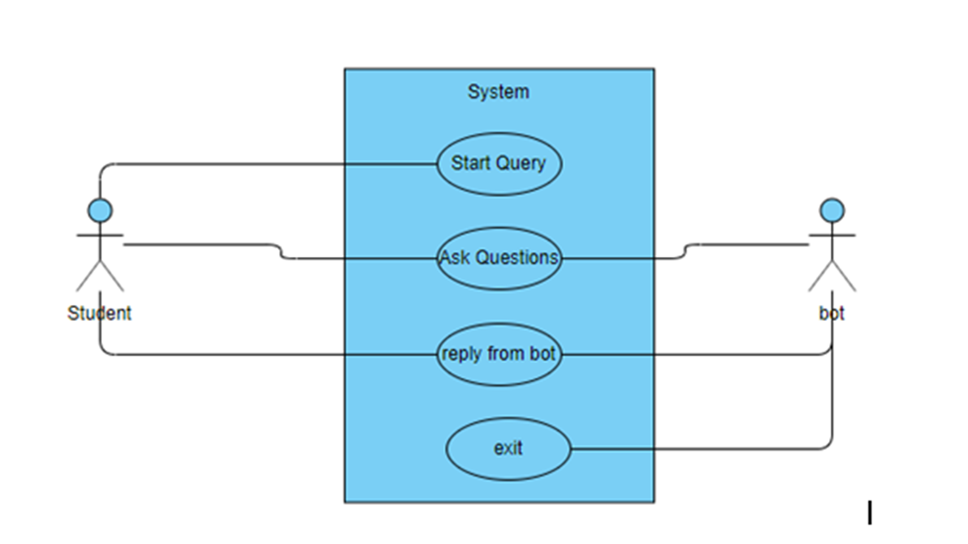

**4.3 Sequence Diagram**

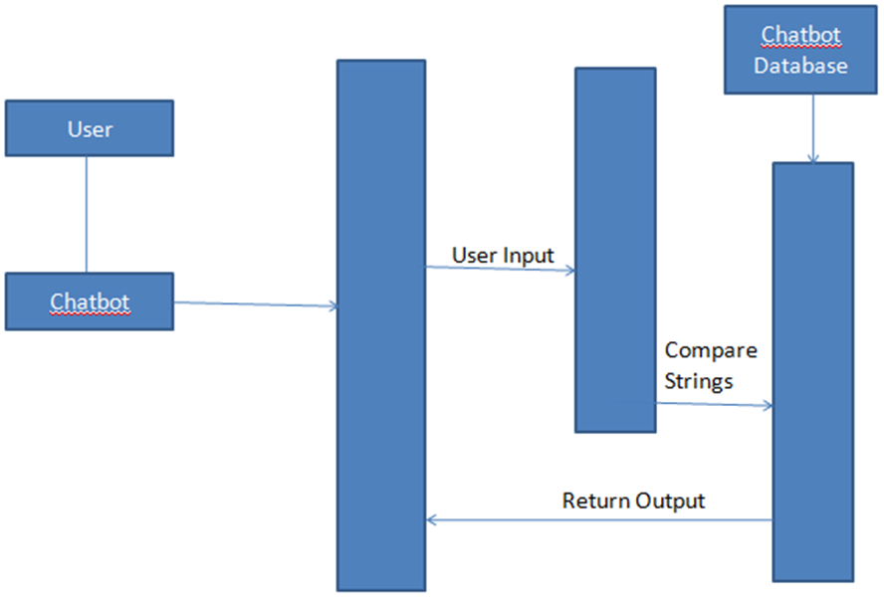

**5. IMPLEMENTATION**

We developed a college chatbot to help students and anyone to get information about the college and students can get their materials related to academic studies

We have developed the system such that, it will automatically parse information from database and can answer questions of students.

**5.1 Sample Code**

**Main.py**

#import modules

from flask import Flask, render_template, request

import os

from chatterbot import ChatBot

from chatterbot.trainers import ListTrainer

from chatterbot.trainers import ChatterBotCorpusTrainer

# Creating ChatBot Instancep

chatbot = ChatBot(

'Buddy',

storage_adapter='chatterbot.storage.SQLStorageAdapter',

logic_adapters=[

'chatterbot.logic.BestMatch',

{

'import_path': 'chatterbot.logic.BestMatch',

'default_response': 'I am sorry, but I do not understand. I am still learning.',

'maximum_similarity_threshold': 1.0

}

],

database_uri='sqlite:///databasefinal111.sqlite3')

# Training with personal Ques & Ans

training_data_college = open('training_data/College.txt').read().splitlines()

training_data_gretting = open('training_data/grettings.txt').read().splitlines()

training_data_more = open('training_data/more.txt').read().splitlines()

#combining all data

training_data = training_data_college + training_data_gretting + training_data_more

trainer = ListTrainer(chatbot)

trainer.train(training_data)

# Training with English Corpus Data

trainer_corpus = ChatterBotCorpusTrainer(chatbot)

app = Flask(__name__)

app.static_folder = 'static'

@app.route("/")

def home():

return render_template("Ngit.html")

@app.route("/bot")

def bot():

return render_template("bot.html")

@app.route("/get")

def get_bot_response():

userText = request.args.get('msg')

userText = userText.title()

# print(userText)

return str(chatbot.get_response(userText))

**Bot.html**

<!DOCTYPE html>

<html lang="en">

<head>

<meta charset="UTF-8">

<title>NGIT BOT</title>

<link rel = "icon" href = "https://image.flaticon.com/icons/svg/327/327779.svg" type = "image/x-icon">

<meta charset="UTF-8">

<meta name="viewport" content="width=device-width, initial-scale=1.0">

<meta http-equiv="X-UA-Compatible" content="ie=edge">

<link rel="shortcut icon" href="#" />

<link rel="stylesheet" href="{{ url_for('static', filename='styles/style.css') }}">

<script src="https://ajax.googleapis.com/ajax/libs/jquery/3.2.1/jquery.min.js"></script>

<style>

table, th, td {

border: 1px solid black;

border-collapse: collapse;

}

</style>

</head>

<body>

<section class="msger">

<header class="msger-header">

<div class="msger-header-title">

</i> NGIT BOT </i>

</div>

</header>

<main class="msger-chat">

<div class="msg left-msg">

<div class="msg-img" style="background-image: url(https://image.flaticon.com/icons/svg/327/327779.svg)"></div>

<div class="msg-bubble">

<div class="msg-info">

<div class="msg-info-name">Your Buddy</div>

<div class="msg-info-time"></div>

</div>

<div class="msg-text">

Hi, Welcome to Neil Gogte Institute of Technology.Ask me about College?

</div>

</div>

</div>

</main>

<form class="msger-inputarea">

<input type="text" class="msger-input" id="textInput" placeholder="Enter your message...">

<button type="submit" class="msger-send-btn">Send</button>

</form>

</section>

<script src='https://use.fontawesome.com/releases/v5.0.13/js/all.js'></script>

<script>

const msgerForm = get(".msger-inputarea");

const msgerInput = get(".msger-input");

const msgerChat = get(".msger-chat");

const BOT_IMG = "https://image.flaticon.com/icons/svg/327/327779.svg";

const PERSON_IMG = "https://image.flaticon.com/icons/svg/145/145867.svg";

const BOT_NAME = "Your Buddy";

const PERSON_NAME = "You";

msgerForm.addEventListener("submit", event => {

event.preventDefault();

const msgText = msgerInput.value;

if (!msgText) return;

appendMessage(PERSON_NAME, PERSON_IMG, "right", msgText);

msgerInput.value = "";

botResponse(msgText);

});

function appendMessage(name, img, side, text) {

const msgHTML = `

<div class="msg ${side}-msg">

<div class="msg-img" style="background-image: url(${img})"></div>

<div class="msg-bubble">

<div class="msg-info">

<div class="msg-info-name">${name}</div>

<div class="msg-info-time">${formatDate(new Date())}</div>

</div>

<div class="msg-text">${text}</div>

</div>

</div>`;

msgerChat.insertAdjacentHTML("beforeend", msgHTML);

msgerChat.scrollTop += 500;

}

function botResponse(rawText) {

$.get("/get", { msg: rawText }).done(function (data) {

console.log(rawText);

console.log(data);

const msgText = data;

appendMessage(BOT_NAME, BOT_IMG, "left", msgText);

});

}

function get(selector, root = document) {

return root.querySelector(selector);}

function formatDate(date) {

const h = "0" + date.getHours();

const m = "0" + date.getMinutes();

return `${h.slice(-2)}:${m.slice(-2)}`;

}

</script>

</body>

</html>

**NGIT.html**

<!DOCTYPE html>

<html lang="en">

<head>

<!-- basic -->

<meta charset="utf-8">

<meta http-equiv="X-UA-Compatible" content="IE=edge">

<!-- mobile metas -->

<meta name="viewport" content="width=device-width, initial-scale=1">

<meta name="viewport" content="initial-scale=1, maximum-scale=1">

<!-- site metas -->

<title>NGIT College</title>

<link rel = "icon" href = "../static/images/logo.png" type = "image/x-icon">

<meta name="Ngit" content="">

<meta name="Student college chatbot" content="">

<meta name="Bals's Team " content="">

<!-- bootstrap css -->

<link rel="stylesheet" href="../static/css/bootstrap.min.css">

<!-- style css -->

<link rel="stylesheet" href="../static/css/style.css">

<!-- Responsive-->

<link rel="stylesheet" href="../static/css/responsive.css">

<!-- fevicon -->

<link rel="icon" href="../static/images/fevicon.png" type="image/gif" />

<!-- Scrollbar Custom CSS -->

<link rel="stylesheet" href="../static/css/jquery.mCustomScrollbar.min.css">

<!-- Tweaks for older IEs-->

<link rel="stylesheet" href="https://cdnjs.cloudflare.com/ajax/libs/font-awesome/4.7.0/css/font-awesome.min.css">

<link rel="stylesheet" href="https://cdnjs.cloudflare.com/ajax/libs/fancybox/2.1.5/jquery.fancybox.min.css" media="screen">

</head>

<body class="main-layout ">

<a href="/bot" class="open-button" target="_blank" ><img src="../static/images/chatbot_img.png" alt="chatbot" width="40px" height="40px"></a>

<header>

<div class="header">

<div class="container">

<div class="row">

<div class="col-xl-3 col-lg-3 col-md-3 col-sm-12 col logo_section">

<div class="full">

<div class="center-desk">

<div class="logo">

<a href="#"><img src="../static/images/logo.png" alt="#" width="179" height="69"></a>

</div>

</div>

</div>

</div>

<div class="col-xl-9 col-lg-9 col-md-9 col-sm-9">

<div class="location_icon_bottum_tt">

<ul>

<li><img src="../static/icon/loc1.png" />Uppal, Kachawanisingaram Village</li>

<li><img src="../static/icon/email1.png" />management.principal@ngit.in</li>

<li><img src="../static/icon/call1.png" />040-29888262</li>

</ul>

</div>

</div>

</div>

<div class="row">

<div class="col-md-12 location_icon_bottum">

<div class="row">

<div class="col-md-8 ">

<div class="menu-area">

<div class="limit-box">

<nav class="main-menu">

<ul class="menu-area-main">

<li class="active"> <a href="">Home</a> </li>

<li> <a href="#about">About</a> </li>

<li><a href="#">Acadamics</a></li>

<li><a href="#">Initiatives</a></li>

<li><a href="#">Contact Us</a></li>

</ul>

</nav>

</div>

</div>

</div>

<div class="col-xl-4 col-lg-4 col-md-4 col-sm-4">

<form class="search">

<input class="form-control" type="text" placeholder="Search">

<button><img src="../static/images/search_icon.png"></button>

</form>

</div>

</div>

</div>

</div>

</div>

</div>

<!-- end header inner -->

</header>

<div id="about" class="about">

<div class="container">

<div class="row">

<div class="col-xl-5 col-lg-5 col-md-5 co-sm-l2">

<div class="about_box">

<h2>About NGIT<br></h2>

<p>Neil Gogte Institute of Technology is the first engineering college to be started after the formation of Telengana state. It is started by Keshav Memorial Technical Educational Society with the sole purpose of promoting quality education from pre primary school to P.G courses.</p>

<p>The present management committee comprises of luminaries having vast experience in different fields from legal to education.

It is a sister concern of KMIT and all the facilities and teaching learning processes will be implemented in the new college.

</p>

<a href="#">Read More</a>

</div>

</div>

<div class="col-xl-7 col-lg-7 col-md-7 co-sm-l2">

<br>

<div class="about_img">

<figure><img src="../static/images/Landscape.jpg" alt="img" /></figure>

</div>

</div>

</div>

</div>

</div>

<div id="product" class="product">

<div class="container">

<div class="container">

<div class="row">

<div class="col-md-12">

<div class="title">

<h2>Ngit <strong class="black"> Images</strong></h2>

</div>

</div>

</div>

</div>

</div>

<div class="container-fluid">

<div class="row">

<div class="col-xl-8 col-lg-8 col-md-8 col-sm-12">

<div class="row">

<div class="col-xl-6 col-lg-6 col-md-6 col-sm-12">

<div class="product_box">

<figure><img src="../static/images/image_1.jpg" alt="#" />

<h3>Administrative block </h3></figure>

</div>

</div>

<div class="col-xl-6 col-lg-6 col-md-6 col-sm-12">

<div class="product_box">

<figure><img src="../static/images/image_2.jpg" alt="#" />

<h3>Play Ground</h3>

</figure>

</div>

</div>

<div class="col-xl-12 col-lg-12 col-md-12 col-sm-12">

<div class="product_box">

<figure><img src="../static/images/image_3.jpg" alt="#" />

<h3>Reading Rooom </h3></figure>

</div>

</div>

</div>

</div>

<div class="col-xl-4 col-lg-4 col-md-4 col-sm-12">

<div class="row">

<div class="col-xl-12 col-lg-12 col-md-12 col-sm-12">

<div class="product_box">

<figure><img src="../static/images/image_4.jpg" alt="#" />

<h3>Library</h3></figure>

</div>

</div>

<div class="col-xl-12 col-lg-12 col-md-12 col-sm-12">

<div class="product_box">

<figure><img src="../static/images/image_5.jpg" alt="#" />

<h3>Labs</h3></figure>

</div>

</div>

</div>

</div>

</div>

</div>

</div>

<div id="contact" class="contact">

<div class="container">

<div class="row">

<div class="col-md-12">

<div class="title">

<h2>Get In <strong class="black"> Touch</strong></h2>

</div>

</div>

</div>

</div>

</div>

<div class="container-fluid padddd">

<div class="col-xl-12 col-lg-12 col-md-12 col-sm-12 padddd">

<div class="map_section">

<div id="map" >

<iframe src="https://www.google.com/maps/embed?pb=!1m18!1m12!1m3!1d3807.338630546436!2d78.6197742139699!3d17.39552928807372!2m3!1f0!2f0!3f0!3m2!1i1024!2i768!4f13.1!3m3!1m2!1s0x3bcb9e51f1202ec3%3A0x805544efd4bd55f!2sNeil%20Gogte%20Institute%20of%20Technology!5e0!3m2!1sen!2sin!4v1613990849306!5m2!1sen!2sin" width="100%" height="600px" style="border:0;" allowfullscreen="" loading="lazy"></iframe>

</div>

</div>

</div>

</div>

<footr>

<div class="footer top_layer ">

<div class="container">

<div class="row">

<div class="col-xl-3 col-lg-3 col-md-6 col-sm-12">

<div class="address">

<a href="#"> <img src="../static/images/logo.png" alt="logo" /></a>

<p>We make your children life Brighter.Trust us </p>

</div>

</div>

<div class="col-xl-3 col-lg-3 col-md-6 col-sm-12">

<div class="address">

<h3>Quick links</h3>

<ul class="Links_footer">

<li><img src="../static/icon/3.png" alt="#" /> <a href="#"> Join Us</a> </li>

<li><img src="../static/icon/3.png" alt="#" /> <a href="#">Maintenance</a> </li>

<li><img src="../static/icon/3.png" alt="#" /> <a href="#">Courses</a> </li>

<li><img src="../static/icon/3.png" alt="#" /> <a href="#">Placements</a> </li>

<li><img src="../static/icon/3.png" alt="#" /> <a href="#">Branches</a> </li>

</ul>

</div>

</div>

<div class="col-xl-3 col-lg-3 col-md-6 col-sm-12">

<div class="address">

<h3>Subcribe email</h3>

<p>To get notified drop your email here </p>

<input class="form-control" placeholder="Your Email" type="type" name="Your Email" >

<button class="submit-btn">Submit</button>

</div>

</div>

<div class="col-xl-3 col-lg-3 col-md-6 col-sm-12">

<div class="address">

<h3>Contact Us</h3>

<ul class="loca">

<li>

<a href="#"><img src="../static/icon/loc.png" alt="#" /></a>kachavanisingaram

<br>uppal </li>

<li>

<a href="#"><img src="../static/icon/email.png" alt="#" /></a>management.principal@ngit.in</li>

<li>

<a href="#"><img src="../static/icon/call.png" alt="#" />040-29888262</a> </li>

</ul>

</div>

</div>

</div>

</div>

</div>

<div class="copyright">

<div class="container">

<p>Design By Bala's Team</p>

</div>

</div>

</footr>

<script src="../static/js/jquery.min.js"></script>

<script src="../static/js/popper.min.js"></script>

<script src="../static/js/bootstrap.bundle.min.js"></script>

<script src="../static/js/jquery-3.0.0.min.js"></script>

<script src="../static/js/plugin.js"></script>

<script src="../static/js/jquery.mCustomScrollbar.concat.min.js"></script>

<script src="../static/js/custom.js"></script>

<script src="https:cdnjs.cloudflare.com/ajax/libs/fancybox/2.1.5/jquery.fancybox.min.js"></script>

</body>

</html>

**College.txt( training file)**

Attendance

We are Updating

Exam Notifications

visit <a href="https://www.ouexams.in/press" target="_blank">notifications</a>

Mids

27th Feb to 3rd March

Cie

27th Feb to 3rd March

Branches

Curently we have only 3 streams on going we will make them more<ol><li><a href="http://ngit.ac.in/departments.php" target="_blank">CSE</a></li><li><a href="http://ngit.ac.in/departments.php" target="_blank">IT</a></li><li>CSE-AI&ML</li></ol>

3-1 Materials

<a href="https://drive.google.com/drive/folders/1R1q462Az7xsNTSDUwt3Mq0anG3bIwmpB?usp=sharing" target="_blank"> 3-1 Materials</a>

Soft Computing

<a href="https://drive.google.com/drive/folders/1Eip-_KBNDcfOa_kNN4nWHAXIWVA-fy7m?usp=sharing" target="_blank"> Soft Computing</a>

Operating System

<a href="https://drive.google.com/drive/folders/1Yuz4nxcicOSuVivmPURCeBXq6VcIev8h?usp=sharing" target="_blank"> Operating System</a>

Artificial Intelligence

<a href="https://drive.google.com/drive/folders/1SkOuv-sq26-Of-0-jSvW_upMfMy1jvyK?usp=sharing" target="_blank"> Artificial Intelligence</a>

Computer Networks

<a href="https://drive.google.com/drive/folders/1WVI5hOZQJEofRzCfyB2oTE7tA6hw3PWJ?usp=sharing" target="_blank"> Computer Networks</a>

Web And Internet Technologies

<a href="https://drive.google.com/drive/folders/1Y3rO6I3vrZynKOFKgNPZ7bvutgdItJ5e?usp=sharing" target="_blank"> Web And Internet Technologies</a>

Automata Language And Computations

<a href="https://drive.google.com/drive/folders/16LkHsEs_tDyTo_s9gzOkyRA6deINpd5J?usp=sharing" target="_blank"> Automata Language And Computations</a>

Software Engineering

<a href="https://drive.google.com/drive/folders/1aruQpRiRGpueepo_MuAmf3nZCiix-qm_?usp=sharing" target="_blank"> Software Engineering</a>

Notice Board

<a href="https://drive.google.com/drive/folders/1vsGHR7dTPEHdfSrJXoZGkY7l51CNYTAt?usp=sharing" target="_blank">Notice Board</a>

Admissions

To know about admissions visit <a href="http://ngit.ac.in/admissions.php" target="_blank">Admissions</a>

Ivth Sem Results

<a href="https://www.osmania.ac.in/res07/20210211.jsp" target="_blank">2-2 sem Results</a>

Results

<a href="https://www.osmania.ac.in/examination-results.php" target="_blank">results </a>

Acdamic Info

<a href="https://www.osmania.ac.in/academic-information.php" target="_blank">Acadamic Info</a>

Can You Tell Me About Acdamic Info

You can visit to know about <a href="https://www.osmania.ac.in/academic-information.php" target="_blank">Acadamic Info</a>

Exams Timtetable

<a href="https://drive.google.com/file/d/1kIcANX7cc8BCkE7au0lmxX1UcwrJHzUA/view?usp=sharing" target="_blank">Exam Timtetable</a>

Google

<a href="https://www.google.com" target="_blank">Google.com</a>

Infrastructure

<a href="https://ngit.ac.in/infrastructure.php" target ="_blank">infrastructure</a>

Cse First Year Syllabus

First year CSE Syllabus<a href="https://drive.google.com/file/d/16hSiFnHwqkywoJ-JBU7dbCkA8qlb1GSH/view?usp=sharing" target="_blank">CSE first year syllabus</a>

Cse Second Year Syllabus

Second year CSE Syllabus<a href="https://drive.google.com/file/d/1e0F9SN5secLcFpI0k2wCmC0jzboH_x9i/view?usp=sharing" target="_blank">CSE second year syllabus</a>

Cse Third1 Year Syllabus

Third year CSE Syllabus<a href="https://drive.google.com/file/d/1KQlAeaS-rCkIXzApDx9bZf1r1gZsekzV/view?usp=sharing" target="_blank">CSE second year syllabus</a>

It First Year Syllabus

First year IT Syllabus<a href="https://drive.google.com/file/d/19tGI6XOYw6aDEjoDzwxabCJ75fvlyQcc/view?usp=sharing" target="_blank">First IT year Syllabus</a>

It Second Year Syllabus

First second IT Syllabus<a href="https://drive.google.com/file/d/1nwre5GoPWCyULhENTcfAIzIyi2NIfXG0/view?usp=sharing" target="_blank">Second IT year Syllabus</a>

It Third1 Year Syllabus

Third second IT Syllabus<a href="https://drive.google.com/file/d/1VAwqqiTD5xAeogjmct-WjSG4ef3TowrR/view?usp=sharing" target="_blank">Third IT year Syllabus</a>

Lab Externals

Not yet decided

Phone Number

Contact us:9100965022 / 040-29888262.

Eamcet Code

Ngit

Address

NGIT GOGTE INSTITUTE OF TECHNOLOGY Survey No 35 ,Kanchivanisingaram village,parvathapur,Peerzadiguda, Uppal, Hyderabad, Telangana 500039,Telephone :040-29888262,Mobile:9100965022.

What Is Fs?

FS stands for Finishing School. The Finishing School is run concurrently with the B.Tech course, unlike other Finishing schools which are offered after the completion of B.Tech.Finishing School for the First batch of NGIT students was started in June 2019 itself .They will graduate in 2021.As you know , KMIT Placements are one of the Best.Same will follow for NGIT.

What Is Sonet?

SONET stands for School Of New & Emerging Technologies. Around 2000 students trained in 2017-18 Academic year.It offers following courses.The SONET Program teaches the courses like HADOOP , DATA SCIENCE/ MACHINE LEARNING , INTRODUCTION TO MATLAB AND OCTAVE, VLSI DESIGN IN MATLAB, DIGITAL SIGNAL PROCESSING USING MATLAB , SALESFORCE ,WEBSECURITY, NOSQL,UNITY, BLOCK CHAIN, AEM,IOT

What Is Cwd?

CWD stands for Customized Workforce Development.To survive in today's highly competitive world, it has become imperative for graduates to have certain edge. Recognizing the importance of this, and the fact that communication skills play a major role in recruitments.In the CWD program, the students selected by Recruiting Companies are taught the special skills required by the company , in the college itself.

What Is Trishul?

With the sole objective of producing industry ready engineering students. NGIT has instituted a comprehensive Trishul program for its First year students. We believe that this program will go a long way in bridging the industry-academia gap that all of us are so well aware of. The Trishul program is run concurrently with the B.Tech course

Location

GO to <a href="https://goo.gl/maps/ju6yGJfotqiBN2j9A" target="_blank">NGIT Directions</a>

What Is Bec?

BEC stands for Business English Certificate.To survive in today's highly competitive world, it has become imperative for graduates to have certain edge. Recognizing the importance of this, and the fact that communication skills play a major role in recruitments, NGIT offers its students an opportunity to take the Business English Certificate exam, an ESOL exam conducted by Cambridge University, more commonly known as BEC.

Placements

NGIT's first final year batch will graduate in 2021. The students will be provided the placement opportunities similar to KMIT. Please Visit <a href="https://www.kmit.in/placements" target="_blank">KMIT Placements</a>

Transport

NGIT provides a very hygienic, punctual and safe bus services which run across the City. There are 11 buses in this academic year and will raise the number of buses every year.Online tracking of buses is available for students in Netra app.<a href="https://drive.google.com/file/d/1EXdazimRzQnhRSrAVepg-0vFbvX5WDc_/view?usp=sharing" target="_blank">Routes List</a>

Images

visit :<a href="https://drive.google.com/drive/folders/1UFuB4R_S_EqIeADJb8hI9473ALKkG5Vb?usp=sharing" target="_blank">Images</a>

Campus Images

visit :<a href="https://drive.google.com/drive/folders/1UFuB4R_S_EqIeADJb8hI9473ALKkG5Vb?usp=sharing" target="_blank">Images</a>

3rd Year Online Class Recordings

To view online class recordings Visit:<a href="https://drive.google.com/file/d/1k8nS9C_iw8crQmfcAAJjl0-Wc-RcDFJc/view?usp=sharing" target="_blank">Online class Recording</a>

Current College Schedule

<a href="https://drive.google.com/file/d/1i1fDsPPYp-HQdHPjc7EYo4iaPKvicpAe/view?usp=sharing" target="_blank">Current Schedule</a>

Principal

Professor Dr Jaya Prakash.<br> Contact: 9502669317

College Timings

9:30 to 16:30

Chemistry Faculty

<table><tr><th>Faculty</th><th>Teaching to Year</th></tr><tr><td>Padmavathi</td><td>1, 2,3, 4</td></tr><tr><td>Bharath</td><td>2, 4</td></tr><tr><td>Kalyani</td><td>1</td></tr><tr><td>Kiran</td><td>1,2,3</td></tr><tr><td>Prakash</td><td>1,2</td></tr></table>

**6. TESTING**

|  |  |
| --- | --- |
| **Input** | **Output** |
| **Hi** | **Hello, I am Bot** |
| **Bye** | **See You again** |
| **Gffgak** | **Sorry, I didn’t get you, I am still learning** |
| **It third year syllabus** | **Drive link** |

**7. SCREENSHOTS**

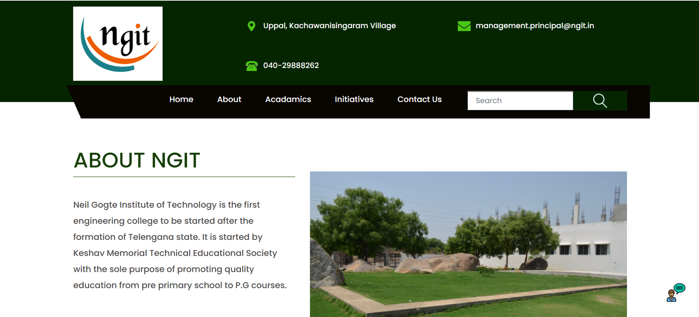

**Directory Tree**

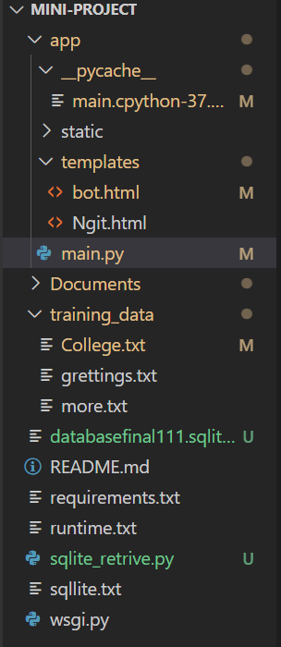

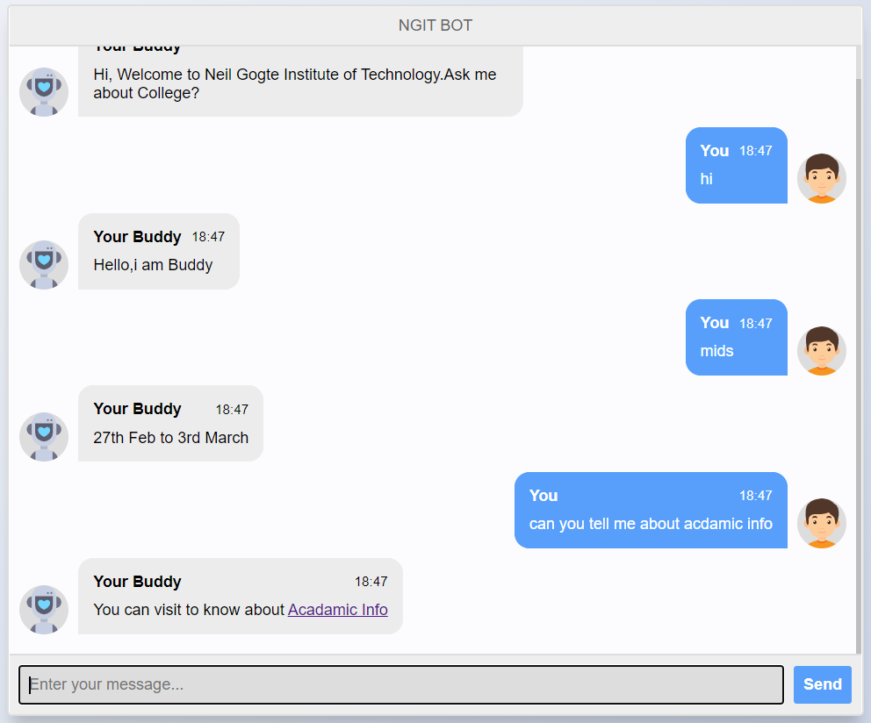

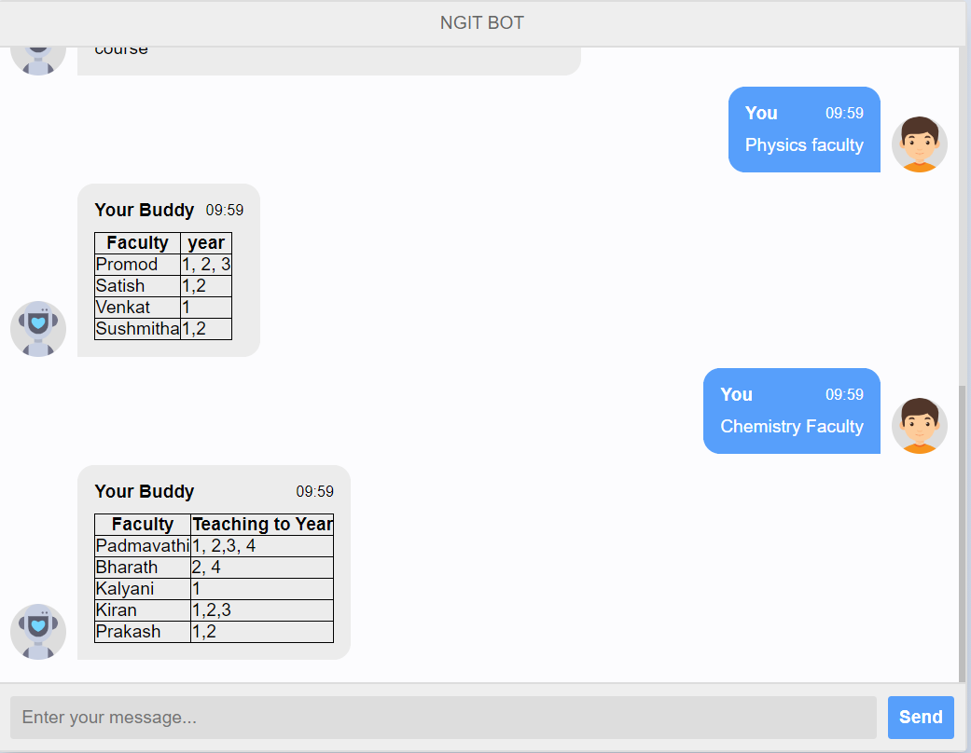

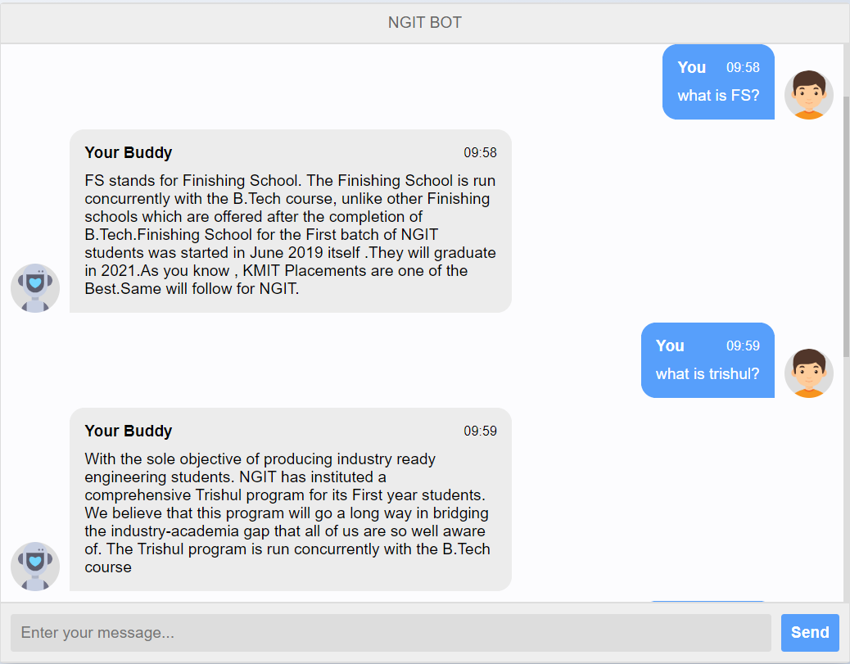

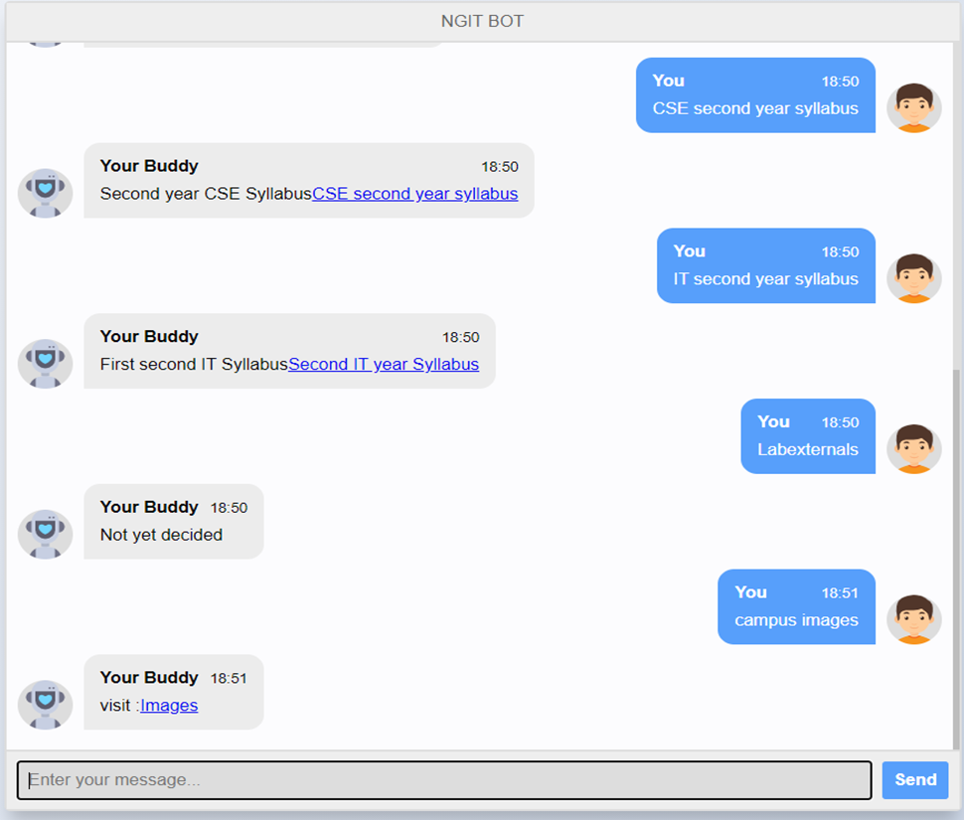

**8. CONCLUSION & FUTURE SCOPE**

From my perspective, chatbots or smart assistants with artificial intelligence are dramatically changing businesses. Chatbots can reach out to a large audience on messaging apps and be more effective than humans. They may develop into a capable information-gathering tool in the near future. We make our chatbot to accept human speech and give the accurate results according to the speech given by user and will make the bot to talk just as Alexa, Google’s Assistant, Apple’s Siri.

**BIBILOGRAPHY**

1. ["What is a chatbot?"](http://searchdomino.techtarget.com/sDefinition/0,,sid4_gci935566,00.html). techtarget.com.
2. Luka Bradeško, DunjaMladenić. ["A Survey of Chabot Systems through a Loebner Prize Competition"](https://pdfs.semanticscholar.org/9447/1160f13e9771df3199b3684e085729110428.pdf) (PDF).
3. Orf, Darren. ["Google Assistant Is a Mega AI Bot That Wants To Be Absolutely Everywhere"](https://gizmodo.com/google-assistant-is-a-mega-chatbot-that-wants-to-be-abs-1777351140).
4. ["The 8 best chatbots of 2020"](https://www.techomoro.com/top-10-ai-chatbots/).
5. ["An Overview of Conversational AI"](https://georgianpartners.com/investment-thesis-areas/overview-conversational-ai/).

**APPENDIX**

**TOOLS AND TECHNOLOGY**

**PYTHON:**

Python is an interpreted, high-level and general-purpose programming language. Python's design philosophy emphasizes code readability with its notable use of significant indentation.

**Flask:**

Flask is a micro web framework written in Python. It is classified as a microframework because it does not require particular tools or libraries. It has no database abstraction layer, form validation, or any other components where pre-existing third-party libraries provide common functions.

**Chatterbot:**

A chatbot is a software application used to conduct an on-line chat conversation via text or text-to-speech, in lieu of providing direct contact with a live human agent. A chatbot is a type of software that can automate conversations and interact with people through messaging platforms.

**SQLite3:**

SQLite is a relational database management system contained in a C library. In contrast to many other database management systems, SQLite is not a client–server database engine. Rather, it is embedded into the end program.

**HTML:**

Hypertext Markup Language is the standard markup language for documents designed to be displayed in a web browser. It can be assisted by technologies such as Cascading Style Sheets and scripting languages such as JavaScript.

**CSS:**

Cascading Style Sheets is a style sheet language used for describing the presentation of a document written in a markup language such as HTML. CSS is a cornerstone technology of the World Wide Web, alongside HTML and JavaScript.

**JavaScript:**

JavaScript, often abbreviated as JS, is a programming language that conforms to the ECMAScript specification. JavaScript is high-level, often just-in-time compiled, and multi-paradigm. It has curly-bracket syntax, dynamic typing, prototype-based object-orientation, and first-class functions